Activity
Company
Location

DO NOT undertake this work unless you have been trained and authorised.

Protective Equipment

Potential Hazards

Pre-Operation

Safe Operation

Post-Operation

Verification of Competence
I verify that I have observed the trainees named below operating the tractor in accordance with this Safe Work Procedure. Based on these observations I have made the following assessments of their competence:
Trainee | Trainer | Date | Competent
 |  |  | Yes No
 |  |  | Yes No
 |  |  | Yes No
 |  |  | Yes No

Protective Equipment Pictograms
 |  | 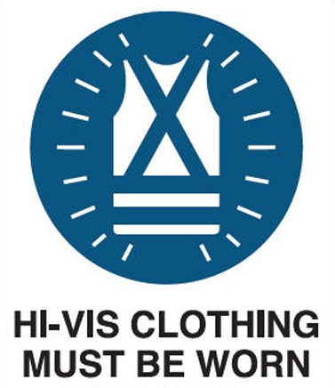 |  |  | 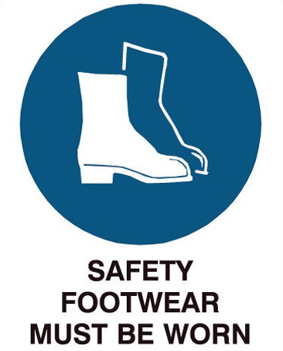
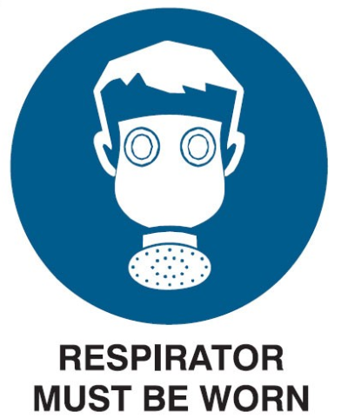 | 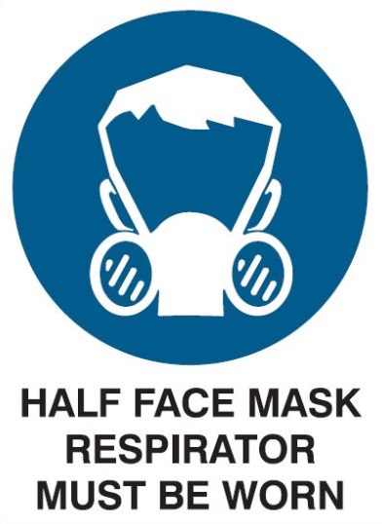 |  |  |  |  | 