16 April 2020

Dear Valued Team Members,

In last week’s update, we acknowledged that many candidates had questions about car pooling and interstate travel. Here is some key information to help make things clearer:

Car Pooling

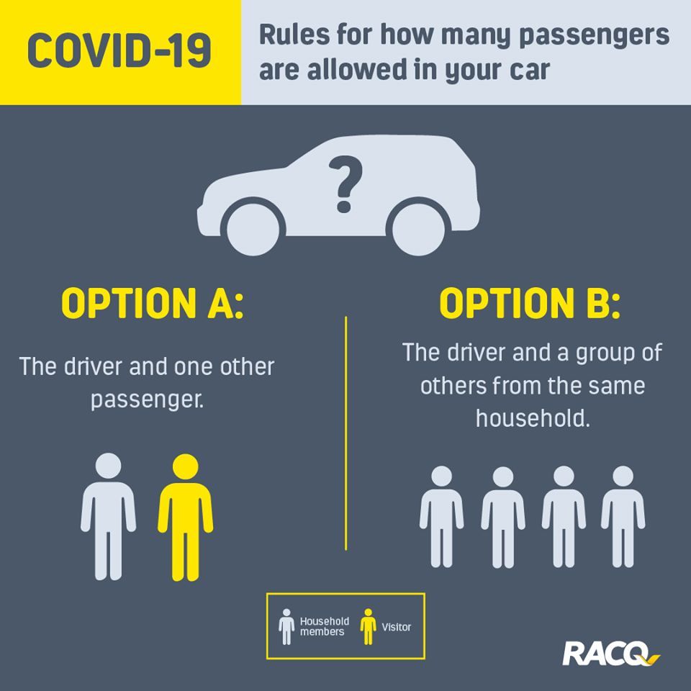

Relocating from One Place to Another

Each state and territory have different rules about who can enter and who needs to self-isolate upon arrival. We’ve found this great website that has these rules all in one place:

https://www.interstatequarantine.org.au/state-and-territory-border-closures/

For More Information

- We recommend everyone downloads the Australian Government Coronavirus App

- Visit the federal governments Coronavirus website:
https://www.health.gov.au/news/health-alerts/novel-coronavirus-2019-ncov-health-alert

- If you want to speak to someone call the Coronavirus Helpline: 1800 020 030 (open all hours)

