26 March 2020

Dear Valued Team Members,

Agri Labour Australia is taking the Coronavirus threat seriously and we are committed to taking all reasonable steps to protect our people, clients and the communities in which we operate. We are staying informed of the advice provided by the Department of Health (https://www.health.gov.au/) and the World Health Organisation (https://www.who.int/) and continue to follow their recommendations at all times.

What You Need to Know

- There have been no reported cases of Covid-19 in Agri Labour Australia or at the client locations where our people are working.
- No Agri Labour Australia worker has lost their job as a result of business closures and social distancing measures.
- Agri Labour Australia is committed to protecting your job and to ensuring our community continues to receive the food and services we help to produce.
- Agri Labour Australia is working closely with each of our clients to ensure we are prepared to respond to any suspected cases of Covid-19.
- The number of cases of Covid-19 continue to increase in Australia which means social distancing and personal hygiene measures are now more important than ever.
- The closure of some state and territory borders will not prevent workers from crossing borders if required to get to and from work.

How You Can Help

- Stay informed by checking reliable sources of information such as health.gov.au.
- Complete the online Coronavirus Prevention training Agri Labour Australia rolled out yesterday.
- Keep in touch with friends and family to make sure they’re well.
- Read the attached guide Simple Steps to Reduce the Risk of Coronavirus.
- If you develop a fever, sore throat, fatigue or difficulty breathing then go straight home, self-isolate and seek medical attention.
- Read the attached guide How To Self-Isolate. If you are required to self-isolate, you must strictly follow these guidelines.
- At all times keep your distance from others. This is not a time to socialise or to travel unnecessarily.

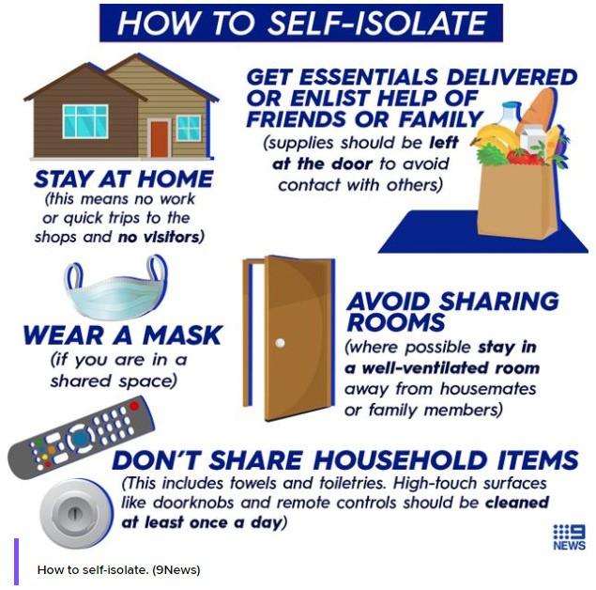
If you want to talk to someone about Coronavirus, call the Coronavirus Health Information Line on 1800 020 030.

Agri Labour Australia will continue to the monitor the situation and provide advice on any changes that may affect our workers. For further information, and updates, please follow this Australian Government website: https://www.health.gov.au/news/health-alerts/novel- coronavirus-2019-ncov-health-alert

If you have any further questions, don’t hesitate to contact us.

Simple steps to reduce the risk of
coronavirus

for yourself and others

Wash your hands often with soap and water, for at least 20 seconds, or use alcohol-based hand rub.

Cough or sneeze

into your elbow or a tissue. Throw the tissue in a rubbish bin and wash your hands immediately.

Avoid close contact with anyone who has fever or a cough.

Stay at home if you feel sick. If you have a fever, cough or difficulty breathing call your local doctor or 1800 020 080 for advice.

Have a plan for
your family in case you need to stay home in isolation.

If you are well, you do not need to wear a mask.

Stay calm and do

not panic. Most people who get coronavirus will have mild sickness.

Elderly people and those with existing illnesses are at greatest risk.

Questions? Call the Coronavirus Health Information Line on 1800 020 080.
You can ask for an interpreter in your language.
11 March 2020

